Online Marketing Concepts
Assignment
Name: Jatin Joshi
Subject: Digital Marketing
Task 1: Online Marketing Techniques Used by Two Apps
1. Instagram
Technique used: Influencer Marketing. Instagram encourages popular creators to promote products and trends, which helps new users discover the app through people they already follow and trust. This word-of-mouth effect brings in users organically.
2. Zomato
Technique used: Referral Marketing. Zomato offers discount coupons when an existing user invites a friend to join, so both users benefit. This motivates people to actively spread the app to their contacts, growing the user base quickly.
Task 2: Digital Flyer for a New Food Delivery App Launch
I designed a launch flyer for a fictional food delivery app called "QuickBite", covering three online marketing concepts: a referral code, a limited-time offer, and an influencer shoutout.
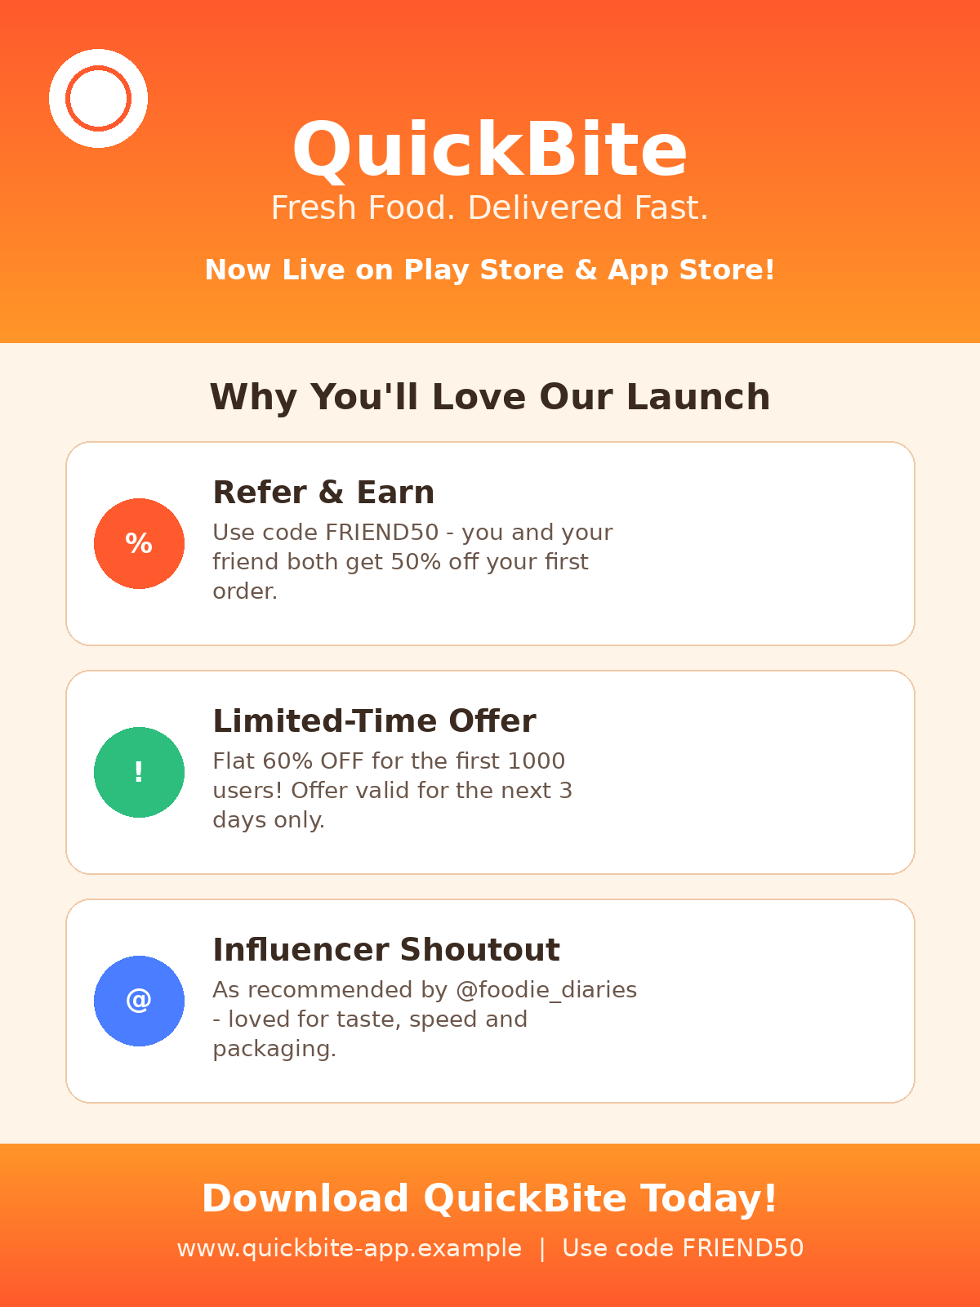
Task 3: Five Types of Online Ads I Have Seen
- Skippable Video Ad - Seen on YouTube before a video starts. It was noticeable because of the loud music and bright visuals, and I could skip it after 5 seconds.
- In-Feed Photo Ad - Seen on Instagram between regular posts. It looked like a normal post but had a small "Sponsored" label, and I could not skip it, only scroll past it.
- Story Ad - Seen on Instagram Stories. It was full-screen and noticeable because it appeared suddenly between friends' stories, with a "Swipe Up" link; it auto-skips after a few seconds.
- Banner Ad - Seen at the bottom of a news app. It was small and easy to ignore, not skippable, but it stayed fixed on the screen while I scrolled the content.
- Search Ad - Seen on Google Search results. It was noticeable because of the small "Ad" tag next to the link, appearing right above the normal search results; it cannot be skipped, only ignored.
Task 4: Online Marketing Plan for a New Playlist Feature (Music App)
1. Optimize the app store listing and website with SEO keywords like "personalized playlist" and "discover new music" so users searching for these terms find the feature easily.
2. Post engaging social media content (reels, stories) showing how the new playlist feature works and how it personalizes music for each user.
3. Partner with a few music influencers and artists to create and share their own playlists using the feature, encouraging their fans to try it too.
4. Send a targeted email campaign to existing users based on their listening habits, showing them a preview of a playlist made just for them.
5. Track how many users try the feature after each campaign, and boost the best-performing posts with a small paid ad budget to reach more people.

